Medicare Part B - Handling the Call - MED B Team Only

General Information
Medicare Part B Coverage
Mail Order Refill Requirements
Identifying Medicare B Eligible Beneficiaries
Handling a Medicare B Call – MED B Team
Updating the Med B Enrollment Tab
OmniSYS Responsibilities
Plan PPT Info – MDB Missing Cardholder ID Number (Med B OmniSYS)
Resolution Time
Related Documents

Description: This document details the steps needed to handle a call from a Medicare Part B beneficiary.

General Information
Medicare Part B (Medical Insurance) helps cover doctors' services and outpatient care. It also covers some other medical services that Part A does not cover, such as some of the services of physical and occupational therapists, and some home health care. Part B helps pay for these covered services and supplies when they are medically necessary.

The Medicare B Team for CVS/Caremark provides beneficiaries’ answers to their Medicare B covered products through Mail Order. Most beneficiaries have a choice to either bill Medicare B or their Prescription plan. A few clients mandate Medicare B to be billed.

Some Mandatory Medicare B clients are listed below (List is not all inclusive). Refer to the CIF to determine if a Mandatory Medicare B clients :
- City of Chicago
- GEHA
- NALC
- State of Florida

Notes:
- The Medicare B team is part of CVS/caremark and not CMS/ 1-800-MEDICARE (1-800-633-4227). Questions related to the ‘red/white/blue’ card or durable medical equipment should be referred to CMS. Refer to Approved Referral Guidelines to Medicare and Social Security for the appropriate guidelines.
- The Medicare Part B team cannot file grievances on behalf of beneficiaries. To file a grievance, the beneficiary must contact 1-800-MEDICARE (1-800-633-4227). For Commercial beneficiaries, to file a complaint, submit the appropriate RM Task.
- Anyone can be eligible for Medicare that has a disability, end stage renal disease or the age of 65 and older. Beneficiaries are charged a premium for Medicare B each month. Medicare Part A does not have a premium. The beneficiary’s deductible has to be met before Medicare B will pays 80%.

Low Income Cost Share (LICS) does NOT apply to Medicare B.

The Hours of Operation for the CVS/Caremark Medicare B Department are:
- Monday - Friday 7am CST - 6pm CST
- Saturday - 8am CST - 4:30pm CST
- Sunday - Closed

Top of the Document

Medicare Part B Coverage
For a list of Medicare B medications, refer to Medicare B Medication List.

The following are Medicare Part B items NOT handled by CVS Caremark Medicare Part B Team; these are referred to Medicare:
- Doctors visits
- Hospital outpatient care
- Home health care
- Preventative services (Example: Flu Shot)

The following are Medicare Part B Coverage items handled by the CVS Caremark Medicare Part B Team:
Medications to keep certain illnesses from getting worse, for Example:
- Immunosuppresants
- Nebulizer Solutions
- Some Oral Cancer Drugs
- Insulin, if provided through a medically necessary insulin pump
  - Can only be billed via a rebill through CVS Caremark Mail Order.
- Others may apply; see Medicare.gov for information

A Retail FEP Med B edit is in place. This is only for Immunosuppressant and nebulizer medication. The Med B Team will not be the direct contact to receive question calls from the beneficiary or pharmacy. The FEP and Pharmacy Help Desk team will take these calls. The Med B team may receive calls from FEP CCRs to confirm Medicare Part B coverage in MARx. Med B at Mail Order is not being offered.

Items always covered under Med B:
- DME
- Diabetic supplies (Unless specified within a CIF or is a non mandatory client that normally covers diabetic supplies) Note: CVS Caremark cannot bill Med B for diabetic testing supplies.

Insulin:
The only way insulin can be billed to Medicare B is through a rebill. There are some stipulations:
- The beneficiary would need to have a paid claim for the insulin via Medicare D or the commercial account.
- The beneficiary would need to have Medicare Part B per MARx.
- The insulin pump has to have been paid for by Medicare.
- The doctor would have had to deem the insulin pump medically necessary.
- There would be a rebill process. This process can take 6-12 weeks for the beneficiary to be reimbursed (sometimes it can take years).
- Payment is not guaranteed as we are not the 3rd party biller to Medicare.

Diabetic Supplies:
If the beneficiary would like to utilize Medicare B for receiving their diabetic supplies, they must go to a retail pharmacy that accepts Medicare B benefits. Diabetic supplies cannot be filled at Mail Order. Diabetic supplies may also be covered under Commercial Plans. You will need to run a test claim to confirm.

Prescribing/Ordering a Blood Glucose Monitor and Associated Accessories:

Provider Requirements
For Medicare coverage of a blood glucose monitor and associated accessories, the provider must provide a valid prescription (order) which must state to the supplier:
- The item(s) to be dispensed;
- The frequency of testing (“as needed” is not acceptable);
- The physician’s signature;
- The signature date; and
- The start date of the order – only required if the start date is different from the signature date.

For beneficiaries who are insulin-dependent, Medicare provides coverage for up to 100 test strips and lancets every month, and one lancet device every 6 months.

For beneficiaries who are non-insulin dependent, Medicare provides coverage for up to 100 test strips and lancets every 3 months, and one lancet device every 6 months.

Note: Medicare allows additional test strips and lancets if deemed medically necessary.

Items covered due to ESRD and only obtainable at the Dialysis Center:
- Varies; to confirm, contact Melanie Vann with OmniSYS.
- If a beneficiary is questioning this, they can contact Medicare or OmniSYS directly for verification.
Example: Furosemide

Items covered if prescribed within 48 hours of Chemotherapy. Note: Advise the beneficiary that these items should be filled at retail:
- Oral Cancer Drugs & Anti-Emetics

Medication covered if beneficiary had a transplant:
- Prednisone

Note: If a beneficiary has not had a transplant, the Prednisone would need to be filled under the beneficiary s Medicare Part D plan.

Retail Claims for Medicare Part B:
The Medicare B Team is unable to view retail claims processed through Medicare B.
- Not all retail pharmacies will process Medicare B claims.
- The beneficiary needs to verify if the pharmacy will bill Medicare B on their behalf and provide their Medicare Card to the pharmacist.
- The claim will adjudicate in real time and the beneficiary is expected to pay a 20% co-pay (Medicare pays 80%)
- The beneficiary may have secondary coverage through their medical plan that pays 20%. If so, the beneficiary will need to ensure that Medicare has their secondary information on file.

Note: If Medicare does not have secondary information on file, a paper claim will need to be submitted to the secondary payer. These claims will not process through CVS/Caremark since they are adjudicated directly to Medicare.

Specialty Medications:
- The Specialty pharmacy handles their own Medicare B billing.
- Do NOT remove the flag for a specialty medication under any circumstances. The prescription will automatically be removed from our system and processed by the Specialty Pharmacy.
- These calls should be transferred to the Specialty Pharmacy. Refer to Departments & Programs (Phone, Addresses & Hours).

Medicare B beneficiaries are not eligible for any overrides or reships.

Medicare B Deductible Information:
- Medicare B has a deductible that may change from year to year.
- The Medicare Part B deductible:
  - 2023 - $226.00
  - 2022 - $233.00
It is important to remember that the beneficiary’s Medicare B deductible does not apply to Medicare part D.
- The Medicare B team does not have information regarding where beneficiaries are in their deductible phase. B=Beneficiary questions pertaining to deductibles should be sent to Medicare at 1-800-Medicare.
- Medicare B pays 80% of total cost, beneficiary pays 20% of total cost (unless there is a supplemental insurance, then beneficiary may pay less.)

Note: The Medicare B Team is unable to provide any information on supplemental coverage.

Top of the Document

Mail Order Refill Requirements
Medicare B claims are limited to a 30 day supply. Prescriptions are automatically translated from a 90 day to a 30 day supply.

The utilization rate for Medicare part B is 95%, before the beneficiary can place a refill. This is the equivalent to 28-29 days.

In order for the SAT Med B team to request a refill, a beneficiary may only have 10 days or less of medication on hand. Beneficiary s can place their order up to 14 days before they are out of their current supply; however, the pharmacy will not ship the prescription until they have only 10 days left.

If the beneficiary has less than 15, but more than 10 day supply on hand during the refill attestation, the pharmacy will hold the order until it is refillable. Orders will be RTP’d if the beneficiary has 15 or more day supply on hand.

Medicare will not pay a claim if the name or address on file with CVS/Caremark is different from what is displayed in MARx (CMS). In the event the information does not match, the beneficiary will need to call the plan to update this information. Refer to the CIF for plan information.

Reminders:
- Do NOT offer to compensate /reimburse or waive the co-pay at mail or retail for Medicare B drugs.
- Do NOT quote Medicare B co-pays.
- All prescriptions will need a written diagnosis code (ICD code).
- A new diagnosis code is needed for each new prescription for mail order.

There is no TAT for order status as CVS/ Caremark has to bill the third party biller OmniSYS

Utilize the suggested talk track below when placing call to beneficiary:
If… | Then…
Beneficiary is contacted (reached) | Hello, my name is (your name) from CVS Caremark. This call may be monitored for quality purposes.  Perform standard beneficiary authentication. Refer to the Caller Authentication.  We received a prescription for (name). In order to try and process your current Rx’s through Medicare B we need to verify how much of your medication you have on hand.
Beneficiary is contacted (reached) | If beneficiary states they… | Then…
Beneficiary is contacted (reached) | Do not have or Do not use Med B coverage | - Resolve with RF/02.  - Place comments in the Note Pad and Prescription/Claim Order level comments as follows: Pt name, Drug Name, No Med B Coverage or Not using Med B benefit.
Beneficiary is contacted (reached) | Has Med B coverage | Note: If beneficiary is not able to provide the exact amount, then an estimate from the beneficiary of the amount on hand or number of days supply that they have remaining can be taken.  - Notify the beneficiary that their prescription will be processed using the suggested talk track below:  Thank you. We will try to process your order through Medicare B. If the Medicare processing rejects, we will process through your primary carrier if that option is available.  - SX any Med B line(s) that are not already in MX status.  - RF/02 the PSC line.  - Place comments in the Note Pad and Prescription/Claim Order level comments with the days supply on hand: Pt name, Drug Name, Days on hand as of Date##/##/#### (date used will be the day the conversation with beneficiary occurred)
Voicemail – Leave Message | This is (name) with a call from CVS-Caremark. I am calling regarding a recent mail order we received in our facility. If you could please return our call at (866) 804-5880 and have reference # (Order number) available. If we do not hear back from you, it may result in your order being delayed or cancelled. Thank you.  - PA the order for 24 hours.  - Update the Note Pad.  - Example: Ln<#>-<drug name>1st att, lmvm to verify the amount of <drug name> beneficiary has on hand  - Place Claim/Order comment: Possible Medicare B Order. Please verify the amount of<drug name> beneficiary has on hand.

Top of the Document

Identifying Medicare B Eligible Beneficiaries
A number of indicators and messages are included in PeopleSafe and the CIF to help CCRs identify Medicare Part B eligible beneficiaries.
The tables below list locations and the Medicare B information located within.

CIF:
Location | Medicare B Information
CIF | The CIF will indicate if the plan is an MAPD Plan.  Refer to the following sections in the CIF for MAPD information:  - Client name description  - Need to Know  - Plan Design Highlights  - Under Maintain Patient Profile  Note: If the client is an MAPD plan, calls should NOT be transferred to the Medicare Part B team, as these claims are processed through the plan, and not separately by Medicare B.

PeopleSafe:
Screen | Medicare B Information
Main Screen | The Main screen will include a Medicare B: ENROLLED or Medicare B: Pending indicator when the beneficiary is eligible. Note: These indicators are only visible for Commercial clients.  - Medicare B: Enrolled - indicates that the necessary paperwork (AOB) is on file and the beneficiary is enrolled in Medicare Part B.  - Medicare B: Pending - may indicate an AOB is still required.  - AOB at retail needs to be signed and given to retail pharmacy.  - AOB at mail needs to be signed and mailed to address provided in the letter from OmniSYS.  - Medicare B: Self-Identified - indicates the beneficiary has told CVS Caremark they have Medicare Part B via the mail order form.  Commercial Account Example:  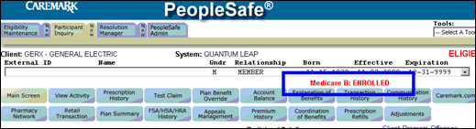  Note: If the account is for a Medicare Part D client, the CCR will only see the existing ‘Medicare D Eligible’ indicator.  - Only one indicator can be shown on the Main screen with Medicare Part D overriding Medicare Part B.  - However, the beneficiary may also be eligible for Medicare Part B.
Test Claim | If the client has opted into Medicare B COB, the Test Claim screen will include an information message: Med B Secondary processing may apply.  Commercial Account Example:  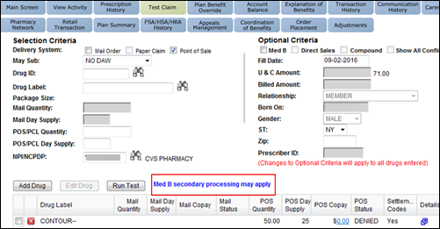  Medicare D Account Example:  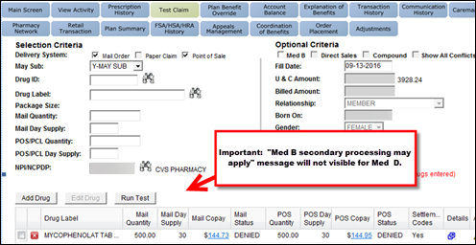  The Test Claim Results may include a Medicare Part B-related settlement code:  Commercial Account Example:  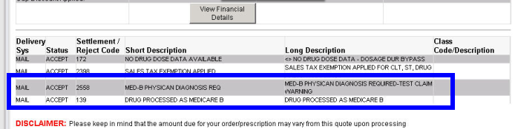  Medicare D Account Example:  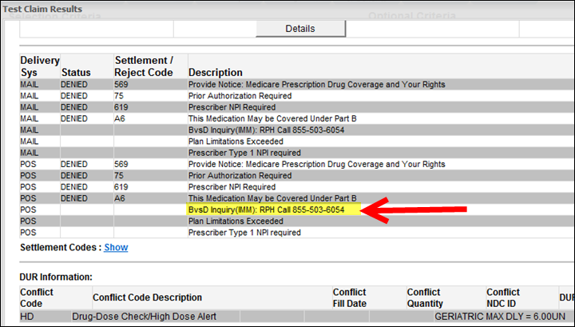  - It will display a PREAUTH REQUIRED settlement code instead.  - The CCR should initiate the Prior Authorization process, as needed. Refer to Commercial Prior Authorization (PA) or MED D - Coverage Determinations and Redeterminations (Appeals).  OR  - If the beneficiary insists that Medicare Part B should cover the medication, the CCR will contact the Medicare Part B team.  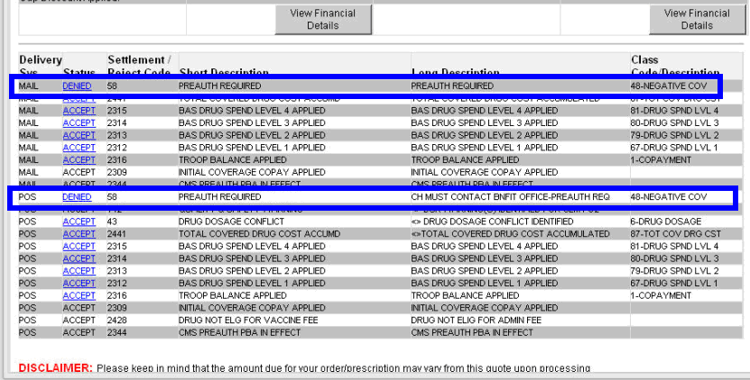
Prescription Refill | The Refill Snapshot on the Prescription Refill screen will include a Med B column to indicate if the drug is Medicare Part B eligible.  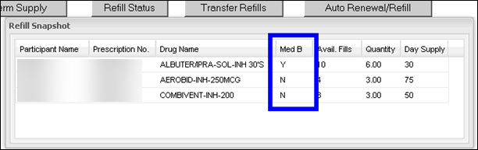
Maintenance Choice Transfer | The Maintenance Choice Transfer screen will also include a Med B column to indicate if the drug is Medicare B eligible.  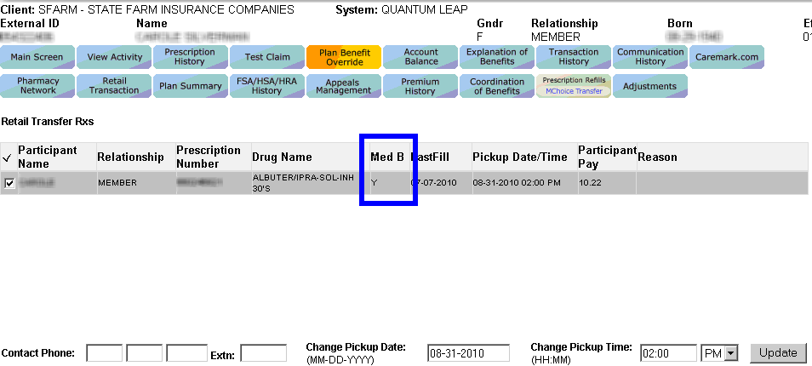.
View Problems | When checking the status of an order, check:  - View Problems, Order Level and Prescription Level Comments.  MedB Attestation – CVS Caremark’s pharmacy reaches out to the beneficiary to verify the day supply on hand prior to releasing a Medicare B order.  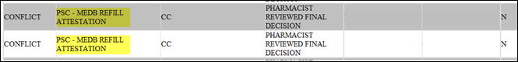

Top of the Document

Handling a Medicare B Call – MED B Team

Refer to the chart below to identify calls handled by the Medicare B team and calls that will need to be transferred to Medicare at 1-800-633-4227:
Handled by Medicare B Team | Transferred to Medicare
Medicare B covered medications | Enrollment into Medicare
Medicare B co-pays | Medical or Hospital Coverage
Medicare B Adjustments | Durable Medical Equipment that cannot be sent through mail (Examples: Wheel chair, beds, shoes, etc.)
AOB concerns

Opt In/Out of Medicare B

Upon receiving the call (transfer from Customer Care or directly), the MED B CCR will:
Step | Action
1 | Thank you for calling CVS/Caremark’s Medicare B Department.  Authenticate the caller. Refer to the following documents:  - Caller Authentication  - HIPAA Authentication Grid
2 | Ask probing questions to determine if the beneficiary is calling about a Medicare Part B issue. For a list of Medicare B medications, refer to Medicare B Medication List.
2 | If… |  |  | Then…
2 | No |  |  | - Determine the reason for the call, and WARM transfer to the customer service number in the CIF, if applicable.  - Proceed to step 6.
2 | Yes |  |  | Proceed to next step.
3 | Determine if the beneficiary has an active Med D or Commercial account in PeopleSafe. If active, ELIGIBLE will display in the top right corner of the PS Main screen.  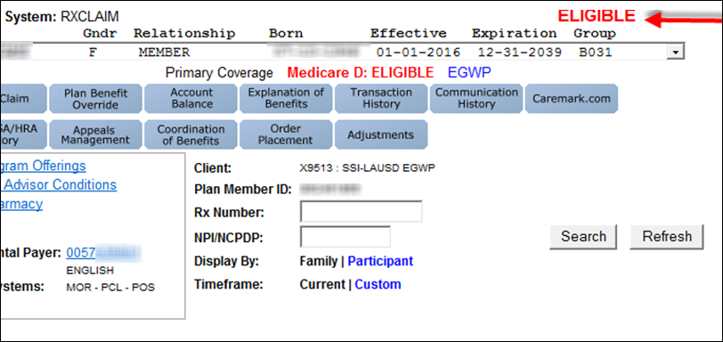  Ensure all High Priority comments are reviewed for pertinent information.
3 | If… | Then…
3 | No | - CCR will refer to CIF to determine who handles eligibility.  - If handled by client, refer caller to client.  - If handled by CVS, refer to:  - MED D - SilverScript - Real Time Resolution of Eligibility  - MED D - Blue MedicareRx (NEJE) - Real Time Resolution of Eligibility  - Proceed to step 6.
3 | Yes | Proceed to next step.
4 | Determine the reason for the call:
4 | If Beneficiary is calling about … |  |  |  |  | Then…
4 | Questions pertaining to their Med B deductible |  |  |  |  | CCR will check MARx for eligibility.  Refer to MED D - Verifying Enrollment, Eligibility and LIS in MARx.  - If MARx indicates eligible, advise the beneficiary to contact his/her State Health Insurance Assistance Program (SHIP).  - Refer to the SHIP National Technical Assistance Center Website at www.shiptacenter.org for more information on contacting state SHIP offices.  - OR  - Visit the website to provide the number for the beneficiary’s local SHIP office, based on the state they live in.  - If MARx indicates not eligible:  - Advise caller coverage is showing it needs to be updated.  - Provide date reflected in MARx.  - Transfer to Medicare 1-800-Medicare.  - Proceed to step 6.
4 | COB |  |  |  |  | CCR will check MARx for eligibility.  Refer to MED D - Verifying Enrollment, Eligibility and LIS in MARx.  - If MARx indicates eligible, Advise caller you must transfer the call to Medicare Coordination of Benefits (COB) Recovery Call Center.  - Cold transfer 1-855-798-2627.  - If MARx indicates not eligible, advise caller you must transfer the call to Medicare.  - Cold transfer the call to 1-800-Medicare.  - Proceed to step 6.
4 | Medicare Parts A, B or C covered items or services, for Example: Durable medical equipment, or has general Medicare questions |  |  |  |  | CCR will check MARx for eligibility.  Refer to MED D - Verifying Enrollment, Eligibility and LIS in MARx.  - If MARx indicates eligible, Advise caller you must transfer the call to Medicare.  - Cold transfer 1-800-Medicare.  - If MARx indicates not eligible:  - Advise caller coverage is showing it needs to be updated.  - Provide date reflected in MARx.  - Transfer to Medicare 1-800-Medicare.  - Proceed to step 6.
4 | An MAPD plan |  |  |  |  | Refer to the CIF or in PeopleSafe under Maintain Patient Profile to confirm the client is an MAPD plan.  - If CIF indicates MAPD plan, CCR will warm transfer call to the Customer Care number listed in the CIF.  - Proceed to step 6.
4 | Status of a Mail order |  |  |  |  | - Access Prescription Detail screen in PeopleSafe.  - Click on View Problems tab to determine the reason for the rejection (missing or invalid).  - View Settlement Codes tab.  - Access View NotePad to review comments.  Click View Comments then select the appropriate prescription number from the Type drop-down list to view prior action on prescription prior to sending email to SAT Med B.  - Example: All attempts made for <scenario> courtesy call made <outcome of call>  Notes:  - If all attempts to contact the prescriber have been made, however, the prescriber has not responded, a new prescription is required or the prescriber can respond to previous correspondence with required information.  - Faxes can only be sent to the confirmed fax number listed on the prescription.  - Prescribers can fax their response to the number provided on the correspondence. Do Not provide fax number verbally.
4 |  |  |  |  |  | If the reason is one of the below… |  |  |  | Then…
4 |  |  |  |  |  | - M/I Diagnosis Code (ICD-10 code)  - Specific Directions  - Date Written  - Prescriber signature |  |  |  | - Send an email to SAT Med B to request the missing information. In the subject line of the email include **securemail** and beneficiary name and ID.  - Include the following in the body of the email:  - Beneficiary name  - Beneficiary ID  - Beneficiary DOB  - Drug in question with the Rx number and order number  - Specific detail regarding what is needed  - Patient Attestation – Number of days’ supply on hand  - Proceed to step 6.  Note: Verbal diagnosis codes cannot be accepted from the physician’s office. In the email to SAT MED B, also include the physicians name and fax number.
4 |  |  |  |  |  | No AOB on file |  |  |  | - Send an email to SAT Med B to request the missing information. In the subject line of the email include the ** securemail** and beneficiary name and ID.  - Include the following in the body of the email:  - Beneficiary name  - Beneficiary ID  - Beneficiary DOB  - Drug in question with Rx number and the order number  - Specific detail regarding what is needed  - AOB Form Needed  - Order#  - Rx#  - Add comments to PeopleSafe indicating date beneficiary called in, and the information provided regarding AOB is needed.  - Review the Med B Enrollment Tab to confirm if Med B flag is present.  - Update as needed. Refer to Updating the Med B Enrollment Tab section.  - Proceed to step 6.
4 | Placing a refill |  |  |  |  | - Ensure the beneficiary is the one that has chosen to OPT In to the Medicare B program. Advise the beneficiary: By opting into the Medicare B program all eligible Medicare B medications will divert in an attempt to process under Medicare B. If the diagnosis is a covered diagnosis, then per Medicare B guidelines, only a 30-day supply will be dispensed.  - Place Notes on the Member Level Comments (Example: Beneficiary Name has chosen to Opt into the Med B Program)  Note: Once the comments have been placed and the Med B flag is turned on, Medicare B will attempt to process the prescription.  - Ask the beneficiary the exact number of days of medication they have on hand.  Per CMS guidelines, we need to verify with the beneficiary the exact amount or day supply prior to shipping a refill for a medication.  - Place Notes on the Member Level View Comment screen in PeopleSafe with as much detail as possible, including Rx #, Order #, and # of days supply on hand.  - Determine the following:
4 |  |  |  |  |  | If… | Then…
4 |  |  |  |  |  | Beneficiary has 14 days supply or less on hand | - Send an email to SAT.MedB@cvshealth.com to request a refill for the medication. In the subject line of the email include the ** securemail** and beneficiary name and ID.  - Include the following in the body of the email:  - Beneficiary name  - Beneficiary ID  - Beneficiary DOB  - Drug in question with Rx number and the order number  - Specific detail regarding what is needed  - Order#  - Rx#  - Review the Med B Enrollment Tab to confirm if Med B flag is present.  - Update as needed. Refer to Updating the Med B Enrollment Tab section.  - Proceed to step 6.
4 |  |  |  |  |  | Beneficiary has 15 days supply or more on hand | - Educate beneficiary on any refill requirements per Mail Order Refill Requirements. Refer to Mail Order Refill Requirements section. Advise the beneficiary to call back when they have 14 days or less.  Exception: If beneficiary cannot wait for the mail order delivery (Example: On vacation beneficiary will have to pay out of pocket if they are out of medication at this point. As there is no override available for Medicare part B), educate beneficiary on Retail pharmacy options.  - Proceed to step 6.
4 | Asking specifically about Medicare B eligibility |  |  |  |  | CCR will check MARx for eligibility.  Refer to MED D - Verifying Enrollment, Eligibility and LIS in MARx  - If MARx indicates not eligible, advise caller you must transfer the call to Medicare.  - Cold transfer to 1-800-Medicare.  - If MARx indicates eligible, advise beneficiary of eligibility and ask if the beneficiary would like to give the mail order pharmacy permission to bill Medicare.
4 |  |  |  |  |  | If… |  | Then…
4 |  |  |  |  |  | Beneficiary says Yes |  | - Obtain a verbal AOB and update the Med B Enrollment Tab with AOB information.  - Refer to Updating the Med B Enrollment Tab section.  - Educate beneficiary an AOB form will be sent with the first order, and the AOB form must be completed and sent to OmniSYS to the address on the form, prior to the next refill.  - Advise the beneficiary only one override is allowed. If they do not turn in the initial AOB form after the first refill, the Sat Med B pharmacy will try to process it through the plan. If the plan rejects the medication, it could possibly be cancelled (RTP’d) or placed on hold for prior authorization.  - Proceed to Step 6.
4 |  |  |  |  |  | Beneficiary says No |  | - Offer to run a test claim to determine if the Rx drug plan will cover the medication.  - Review the Med B Enrollment Tab to confirm if Med B flag is NOT present.  - Update as needed. Refer to Updating the Med B Enrollment Tab section.  - Proceed to step 5.
4 | Transplant Medication (Examples: Mycophenolate, Prednisone, Prograf, Tacrolimus, Sirolimus, etc…) |  |  |  |  | Did Medicare Part B cover your transplant?  Note: Prednisone will only be covered by Medicare Part B if the transplant was also covered by Medicare Part B.
4 |  |  |  |  |  | If... |  |  |  |  |  | Then...
4 |  |  |  |  |  | Yes |  |  |  |  |  | Proceed to If a Drug will be covered section.
4 |  |  |  |  |  | No, it was covered by private insurance |  |  |  |  |  | - Process under the beneficiary’s active Medicare D plan or Commercial plan.  - Proceed to step 5.
4 | If a Drug will be covered |  |  |  |  | CCR will check MARx for eligibility.  Refer to MED D - Verifying Enrollment, Eligibility and LIS in MARx.  Determine the following:
4 |  |  |  |  |  | If MARx indicates: |  |  |  |  | Then…
4 |  |  |  |  |  | Not eligible and the caller wants the drug covered by Med B |  |  |  |  | - Advise caller you must transfer the call to Medicare.  - Cold transfer to 1-800-Medicare.  - Proceed to step 6.
4 |  |  |  |  |  | Not eligible and the caller wants the drug covered by the Med D plan. |  |  |  |  | - Run a test claim to determine if the Med D plan will cover the medication.  - Proceed to step 5.
4 |  |  |  |  |  | Not eligible and the caller wants the drug covered by the Commercial plan. |  |  |  |  | - Advise caller you must transfer to the Commercial plan.  - Warm transfer the call to the Customer Care number listed in the CIF.  - Proceed to step 6.
4 |  |  |  |  |  | Eligible for Med B and the request is for a drug that Med B covers |  |  |  |  | - Run a test claim to determine if the Rx drug plan will cover the medication.  - Proceed to step 5.
5 | Run a Test Claim for the beneficiary.  - Refer to the MED D - Test Claims work instruction.  - Refer to the Test Claim entry in the Identifying Medicare B Eligible Beneficiaries section of this document for MED B messaging.
5 | If the test claim results show… |  |  |  | Then…
5 | Denied with a Medicare B-related settlement code  (One OR all of the following:  - Prior Authorization Required  - B vs D Inquiry: Call 855-503-6054 (The telephone number provided may vary depending on the client)  - This Medication May be Covered Under Part B) |  |  |  | Verify in the Plan Benefit Override tab if a B vs D determination has been processed.
5 |  |  |  |  | If PBO tab shows… |  |  |  |  |  |  | Then…
5 |  |  |  |  | No B vs D on file |  |  |  |  |  |  | - Refer to the Prior Authorizations section in the CIF and follow the process outlined within.  - Proceed to Step 6.
5 |  |  |  |  | B vs D is approved for Med B |  |  |  |  |  |  | CCR will verify if valid Rx is on file.  Note: Valid prescriptions are visible from the Main Screen under the Order Placement navigation button.
5 |  |  |  |  |  |  |  |  |  |  |  | If… | Then…
5 |  |  |  |  |  |  |  |  |  |  |  | Valid Rx is on file | - CCR will place the order via the Order Placement button.  - Proceed to Step 6.
5 |  |  |  |  |  |  |  |  |  |  |  | Rx is NOT on file | - The prescribing physician must initiate an eFax Faststart, per Medicare guidelines.  - Proceed to Step 6.
5 | Denied with a non related Medicare B settlement code |  |  |  | - Review the prescription to confirm it is not a Medicare B eligible drug.  - Transfer the call to customer care number listed in the CIF.  - Proceed to Step 6.
5 | Claim Paid under the Commercial or Med D plan  (Will show ‘Accepted’ in PS) |  |  |  | - Advise beneficiary drug will pay under Commercial or Med D Rx drug plan.  - Ask if they would like the drug to be paid under the plan.
5 |  |  |  |  | If… |  | Then…
5 |  |  |  |  | Yes |  | - Advise beneficiary you must transfer the call for assistance. Warm transfer the call to the Customer Service number in the CIF.  - Proceed to Step 6.
5 |  |  |  |  | No |  | Determine if the medication is Med B eligible.
5 |  |  |  |  |  |  | If… |  | Then…
5 |  |  |  |  |  |  | Yes |  | - Provide what the yearly Medicare B deductible is and educate the beneficiary on the 20% co-pay the beneficiary would have. Confirm the amount of days supply on hand is 14 days or less on hand.  - Place order.
5 |  |  |  |  |  |  | No |  | Educate the beneficiary the item is not Med B eligible. If the medication is not a Medicare B eligible drug, transfer the call to customer care the number in the CIF.
6 | Ask if there are any other benefit questions.
6 | If… |  | Then…
6 | Yes |  | Address any benefit issues.
6 | No |  | Document and close the call according to current policies and procedures.  Note: All notations from the MED D CCR will begin with ***Medicare B***immediately followed by the actions taken on the call.  Log Activity  701= Eligibility Verification  700 Eligibility Update

Top of the Document

Updating the Med B Enrollment Tab
The Medicare B Enrollment Tab (Role Codes 2209 & 2212) contains the beneficiary's Med B eligibility information. The Med B tab can be updated by the Caremark Med B Team and the Medicare B Customer Care Box, once changes are verified in Marx.

This tab is updated so that claims reject and divert correctly within the pharmacy for Med B Billing, and also when claims are incorrectly rejecting & diverting in the pharmacy Med B Billing, such as when a beneficiary is marked Med B Eligible in error.

The following information is needed to update the Med B Enrollment Tab:
- Medicare Beneficiary Identifier (MBI)
- Medicare B Effective Date
- Verbal statement from the beneficiary that Medicare B is either Primary or Secondary
- Must have Original Medicare B and not enrolled in an MA/MAPD

When is this tab updated?
- When a beneficiary requests Med B Billing (Must have Original Medicare B)
- If the agent receives a call from the SAT MED B pharmacy
- If the account manager makes the request to update the Medicare B tab

To add Med B Eligibility information to Med B Enrollment Tab (AKA Adding the “Med B Flag”), perform the following:
Step | Action
1 | Access the beneficiary’s account in PeopleSafe.
2 | Select the “Medicare B Enrollment” tab between “Participant Inquiry” & “Resolution Manager”.
3 | Ask the beneficiary if Med B is Primary or Secondary.  - Select the “Primary Coverage” or “Secondary Coverage” radio button.
4 | Enter the Medicare Claim Number (MBI) in the “Medicare ID” field.
5 | Enter the Medicare B effective date in the “Effective Date” field.
6 | Select “Save” at the bottom.  Result: The “Medicare Enrolled” field at the top will then show “PENDING” or “Always Eligible” if “Primary Coverage” was selected and will show “PENDING MSP”? if “Secondary Coverage”.
7 | Document in Order Level Comments who requested the flag update, and the reason for the update.

Note: If the Medicare B box is greyed out, the client is a mandatory Medicare B client or it is a MAPD client.

When is the information removed from this tab?
- The eligibility information should be removed if the beneficiary does not want to use Med B.
- If it is causing unnecessary rejections & diverts, so long as the beneficiary confirms they don’t want to use Med B. Note: A statement from the beneficiary such as: “I don’t have Med B” IS sufficient.
- If the beneficiary doesn’t have Original Medicare B, either due to:
  - Being enrolled in an MA/MAPD OR
  - The beneficiary is not eligible for Medicare B. (Verified through MARx).
- Beneficiary does NOT request Med B billing and would like to “opt out” of the Medicare B billing process.

To remove Med B Eligibility information from Med B Enrollment Tab (AKA Removing the “Med B Flag”), perform the following:
Step | Action
1 | Access the beneficiary’s account in PeopleSafe.
2 | Select the “Medicare B Enrollment” tab between “Participant Inquiry” & “Resolution Manager”.
3 | Select the “Secondary Coverage” radio button & check “Working Spouse”.
4 | Select the “Save” button at the bottom, left of the screen.
5 | Select the “Cancel Existing Enrollment” button on the right of the screen.  Result: The “Medicare Enrolled” field at the top will then show “NOT ELIGIBLE”.
6 | Document in Order Level Comments who requested the flag update, and the reason for the update.
7 | Notate in Order Level Comments that the beneficiary wants to “opt out” of Medicare B enrollment billing.
8 | Indicate if the prescription will be filled under the plan now that the Medicare B flag has been removed.
9 | Warm transfer the call to the Commercial number listed in the CIF.

Top of the Document

OmniSYS Responsibilities
OmniSYS is a third-party vendor that CVS Caremark has contracted with to address Medicare Part B claims which need additional information in order to proceed with Claims Adjudication.
- When claims are diverted due to the need for additional information, OmniSYS will be notified.

OmniSYS will send the MED B beneficiary letters and forms in order to obtain the required additional details needed to process the claim(s).
- The beneficiary and the pharmacy will be able to contact OmniSYS directly based on the numbers provided in the correspondence from OmniSYS.
- Beneficiary can contact OmniSYS toll-free at 1-888-264-0163.
- Med B CCRs can contact OmniSYS toll-free at 1-888-266-9165.

The following table will assist the CVS Caremark CCR in determining if the correspondence the beneficiary is questioning came from OmniSYS:
AOB Cover Letter (standard) | AOB Cover Letter - Standard
AOB Cover Letter With Invoice | AOB Cover Letter With Invoice
AOB Cover Letter Without Invoice | AOB Cover Letter Without Invoice
DME Information Form - External Infusion Pump | DME Information Form - External Infusion Pump

When a beneficiary has specific questions regarding a letter or form received from OmniSYS the Med B CCR will WARM transfer the call to OmniSYS for further assistance.
- Refer to the Handling a Medicare B Call - MED B Team section of this document to assist with other Med B issues.

Top of the Document

Plan PPT Info – MDB Missing Cardholder ID Number (Med B OmniSYS)
The conflict forms when the Medicare Beneficiary Identifier (MBI) is not on file.

Perform the steps below to resolve the conflict:
Step | Action
1 | Retrieve the order from the PSC Queue.
2 | Access Notepad to verify if Med B technician provided information related to the MDB Missing Cardholder ID conflict.
3 | Open Medicare B Enrollment tab in PeopleSafe to view MBI field.  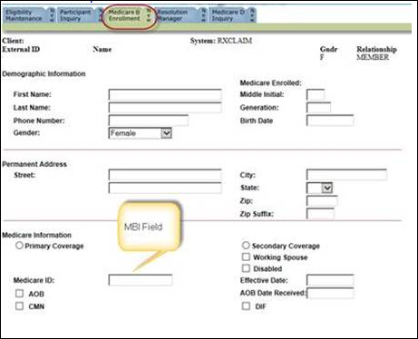
4 | Place call to beneficiary to validate and/or obtain the MBI. Make two attempts.
4 | If… | Then…
4 | MBI is already in the system and is correct, but is still rejecting | - Have the beneficiary call Medicare at 1-800-633-4227.  - Inform beneficiary to call Customer Care to restart the order.
4 |  | If... | Then...
4 |  | New Prescription | Place on Indefinite Hold.
4 |  | Refill | Resolve with RF/08.
4 | MBI is obtained or MBI has changed from what is populated in People Safe. | - Enter new number/changes MBI in PeopleSafe.  - Select the Participant Inquiry New tab.  - Enter the beneficiary’s ID number.  - Select the Med B Enrollment tab.  - Verify the MBI.  - If MBI does not display, select the Primary Coverage radio button and enter the beneficiary’s MBI in the Medicare ID field per the beneficiary.  - Return to the order in LINKS and resolve with RF/02.  - Update Notepad: Ln<#>-<drug name>, <beneficiary name> MBI updated in People Safe per beneficiary <MBI number>  - If the order rejects, have the beneficiary call Medicare at 1-800-633-4227.
4 | Beneficiary is unable to be reached after two attempts | - Resolve conflict with RF/35.  - If the order rejects, resolve conflict with RF/08 (RTP). Beneficiary will receive the Med B Mail Autoletter.
4 | Beneficiary does not have Medicare coverage or does not have a MBI number | - Resolve with RF/35.

Top of the Document

Resolution Time
Information = Immediate
Forms = Up to 7 business days
Transfer to OmniSYS = Immediate
Refill Requests = Varies
Top of the Document

Related Documents
Parent SOP: CALL-0048: Medicare Part D Customer Care Call Center Requirements-CVS Caremark Part D Services, L.L.C.
Abbreviations/Definitions: Abbreviations / Definitions
Top of the Document

Not To Be Reproduced Or Disclosed to Others Without Prior Written Approval
ELECTRONIC DATA = OFFICIAL VERSION – PAPER COPY = INFORMATIONAL ONLY

